Rigoletto plot and character summary

Who are the characters?

The Duke of Mantua – ruler of Mantua
Rigoletto – the Duke’s jester
Gilda – Rigoletto’s daughter
Monterone – an elder statesman
Sparafucile – the Duke’s Head of Security
Maddalena – Sparafucile’s sister

Marullo – a gentleman of the court

Matteo Borsa – a gentleman of the court

Giovanna – Gilda’s governess

Count Ceprano – a gentleman of the court

Countess Ceprano – a lady of the court

The types of voices you will hear

Bass – the lowest male voice type
Monterone and Sparafucile are basses.

Baritone – the middle male voice type
Rigoletto is a baritone.

Tenor – the highest male voice type
The Duke is a tenor.

Mezzo-Soprano – the middle female voice type

Maddalena is a mezzo-soprano.

Soprano – the highest female voice type
Gilda is a soprano.

Everyone will be singing in Italian.
There will be English subtitles at the side of the stage, so you can understand what is going on.

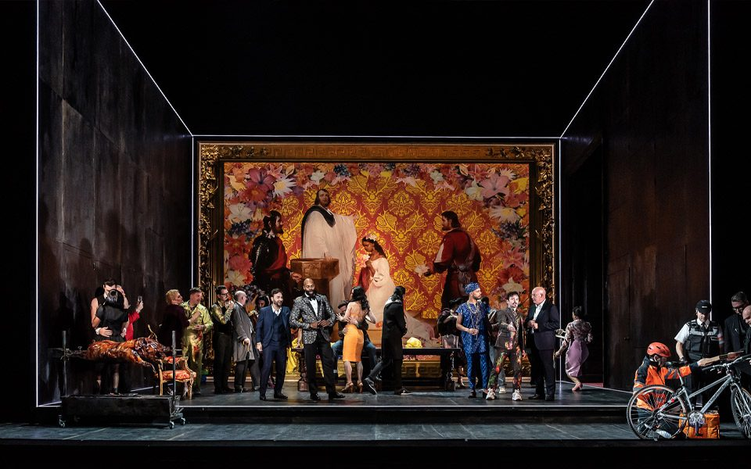
A picture of the Duke of Mantua’s private art gallery, a black room decorated with a vibrant painting. It is packed with people wearing bright costumes.
You can now read the full story of Rigoletto and what happens in each Act.
An Act is a section of the show.

Act 1 (the first part of the show)

The Duke of Mantua is famous for flirting with and chasing women. He is hosting a lively party in his private art gallery. He talks proudly about the women he wants to win over. Rigoletto is his jester. Rigoletto joins in by making cruel jokes about the women’s husbands.

Suddenly, a man named Monterone arrives. He is very angry because the Duke has mistreated his young daughter. Rigoletto makes fun of him as well. Monterone becomes furious and curses Rigoletto.

Rigoletto quickly returns home to check on his daughter, Gilda. He keeps her hidden from the outside world because he wants to keep her safe. But the Duke disguises himself as a poor student and discovers where she lives. He tells Gilda that he loves her. Gilda believes the Duke completely.

Later that night, some of the Duke’s guests decide to take revenge on Rigoletto. They are offended by Rigoletto’s mocking comments. They believe that Gilda is Rigoletto’s secret lover. They plan to kidnap her. They trick Rigoletto into helping them without him realising what is happening. When he finally learns that Gilda has been taken, he is very upset. He thinks that Monterone’s curse is coming true.
The interval will happen after Act 1. The interval is 30 minutes long.
When the interval finishes, Act 2 will begin.
Someone will come to tell you when the show is starting.
They will remind you what happened in the first half.

Act 2 (the second part of the show)

The next morning, Rigoletto goes to the Duke’s palace. He is desperately searching for Gilda. He tries to stay calm, but he is frightened, worried and angry. He begs the people there to tell him where his daughter is. They laugh at Rigoletto and say they will not help him.

Gilda appears. She is upset and very ashamed. She tells her father the truth about what happened between her and the Duke.

Rigoletto is very angry and promises to get revenge on the Duke. But Gilda is still in love with the Duke. She begs Rigoletto to forgive him.

Rigoletto decides that he and Gilda should leave Mantua. This is so they can start a new life away from the Duke. Rigoletto is still angry about what has happened. He secretly continues to plan revenge against the Duke.

Act 3 (the last part of the show)

Rigoletto hires Sparafucile to kill the Duke. Sparafucile plans to make the Duke come to a hideout. He uses his sister Maddalena to attract the Duke.

The Duke arrives and begins flirting with Maddalena. Rigoletto secretly brings Gilda to watch. He hopes she will finally see that the Duke is untrustworthy. Gilda is heartbroken when she sees the Duke and Maddalena. Rigoletto then sends her away to prepare for their escape from Mantua. He agrees the final details of the Duke’s murder with Sparafucile.

But Maddalena likes the Duke now. Sparafucile agrees not to kill the Duke if he can find someone else to kill instead.

Gilda is disguised as a boy and ready to leave with her father. She overhears the plans to kill the Duke. She still loves the Duke and so she decides to sacrifice herself. She enters the house and Sparafucile stabs her. This is because he does not know who she really is.

Rigoletto returns to collect the body because he believes that the Duke has been killed. But when he opens the sack, he is shocked to find Gilda inside. She is badly hurt and she dies. Rigoletto finally realises that Monterone’s curse has come true.

At the end of the show, the cast will come back to the stage and take a bow!

This is the end of the document.

We hope you enjoyed reading and that you found it helpful!

If you have any extra questions, you can ask them by calling our Box Office on 0113 223 3600 or by emailing them at boxoffice@operanorth.co.uk. Our staff are very friendly, and they will be happy to help you.

Thank you for coming to watch Opera North’s production of Rigoletto.

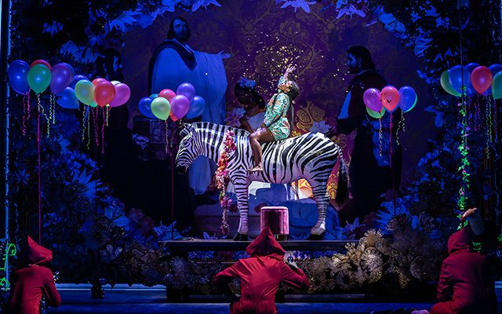
Rigoletto’s daughter, Gilda, happily riding a fake zebra in a very bright and colourful room.

