Your Guide to the Day

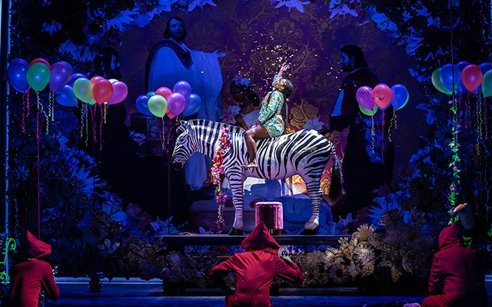 | Relaxed Performance of Rigoletto
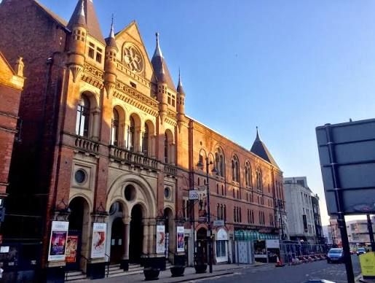 | At Leeds Grand Theatre
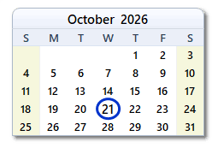  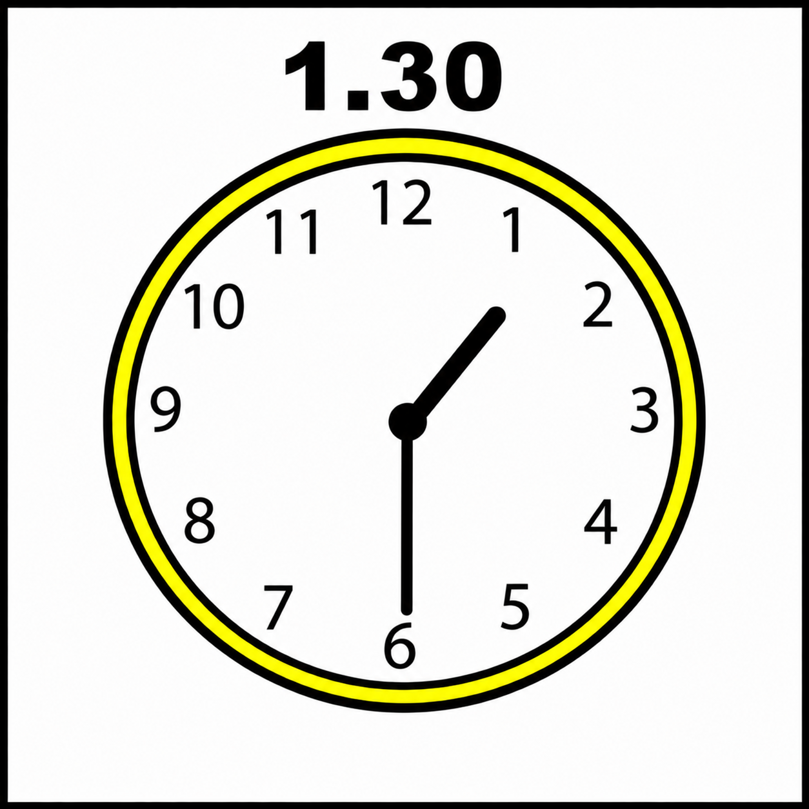 | Wednesday 21st October 2026  1.30pm
Welcome to Leeds Grand Theatre!
 | We are very excited to welcome you to the Leeds Grand Theatre for Opera North’s relaxed performance of Rigoletto.
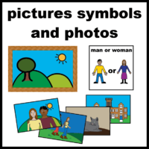 | In this document, there will be some information and images to help prepare you for your visit.
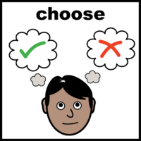 | You don’t have to read everything. The next page has an index which tells you the page numbers of the different sections.
 | You might still have some extra questions at the end.
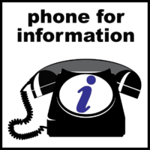   | You can ask your questions by calling our Box Office on 0113 223 3600.  You can also email them at boxoffice@operanorth.co.uk.
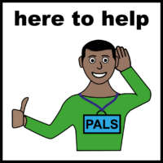 | Our staff are very friendly, and they will be happy to help you.

In this booklet, you can find lots of information.
The page numbers here show you where you can find everything.

Timetable 5
How to get there 6
Picking up your tickets 7
Arriving at the theatre 8
Moving around the theatre 10
Food and drink 11
Quiet Spaces 12
Toilets 13
What the seats are like 14
What happens when the show starts 16
What happens during the show 17
The interval 20
What happens at the end of the show 21
Leaving the theatre 22
The End 24

Timetable
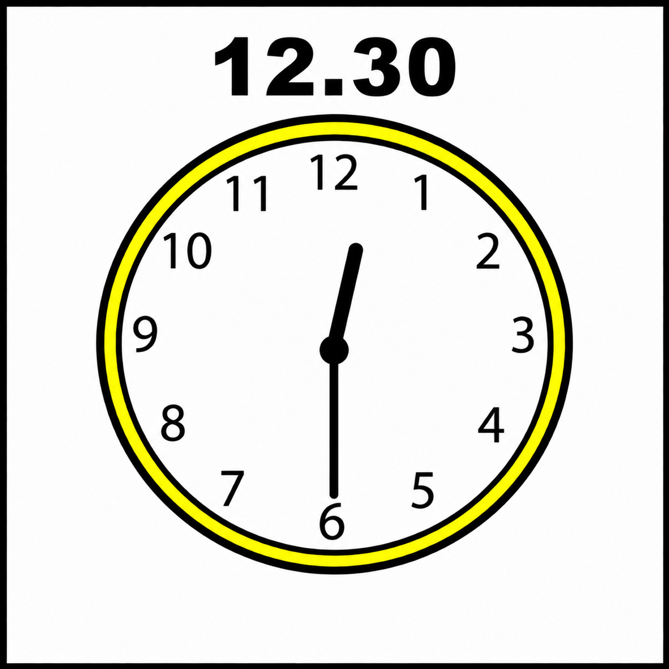 | The theatre will open at 12.30pm. Please make sure you do not arrive before this.
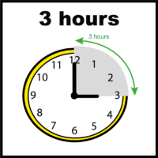 | The show will be about 3 hours long. This includes the interval. Interval means a break from the show.
 | The show will start at 1.30pm.
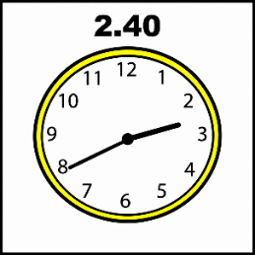 | The interval starts at about 2.40pm.
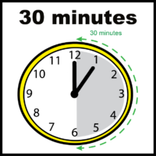 | The interval will be 30 minutes long.
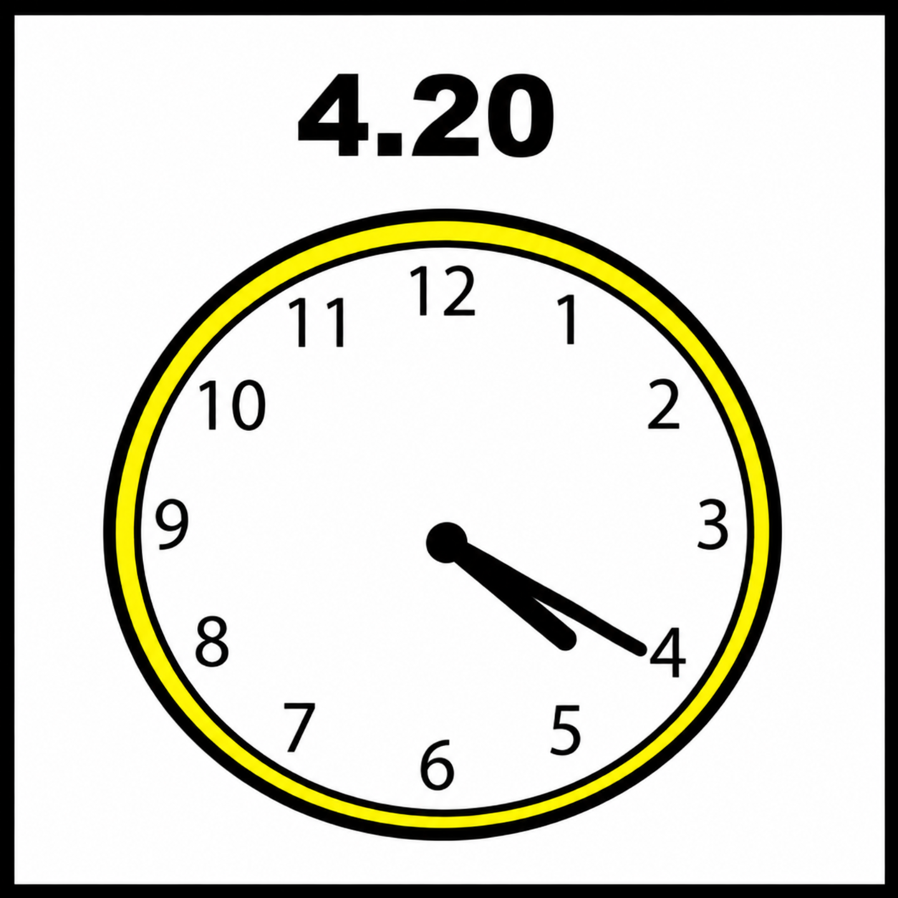 | The show finishes at about 4.20pm.

Information about the theatre

How to get there
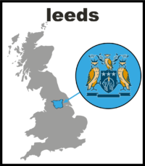 | Leeds Grand Theatre is on New Briggate in Leeds city centre.  There are lots of different ways you can travel to Leeds Grand Theatre.
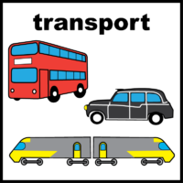 | You might use a bus, a taxi, a train, a car, or you might walk.  Talk to your group about how you will be getting here.
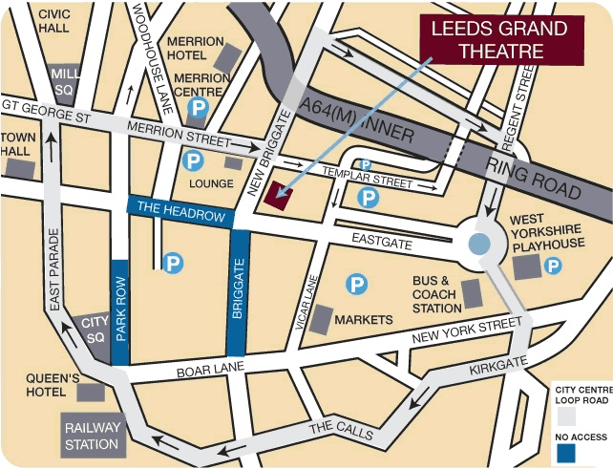 | This picture shows where Leeds Grand Theatre is on a map.  You can find some information about where to be dropped off and picked up on our website.

Picking up your tickets
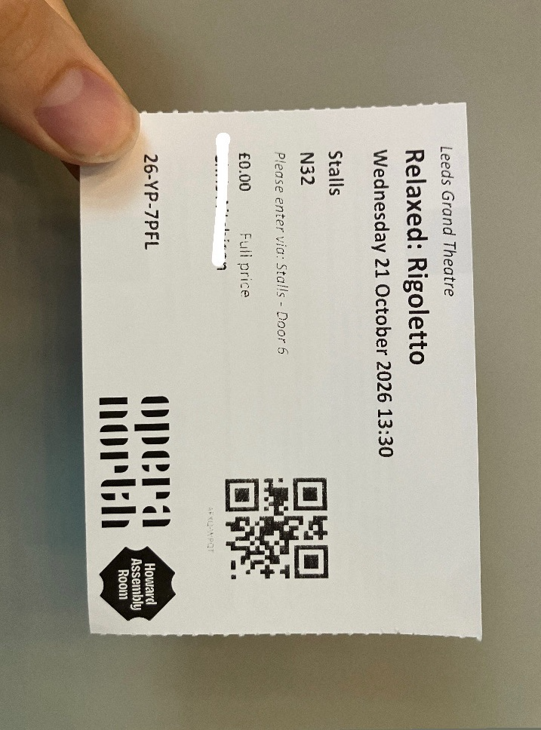 | If you don’t already have your tickets, you can collect them from the Opera North Box Office.
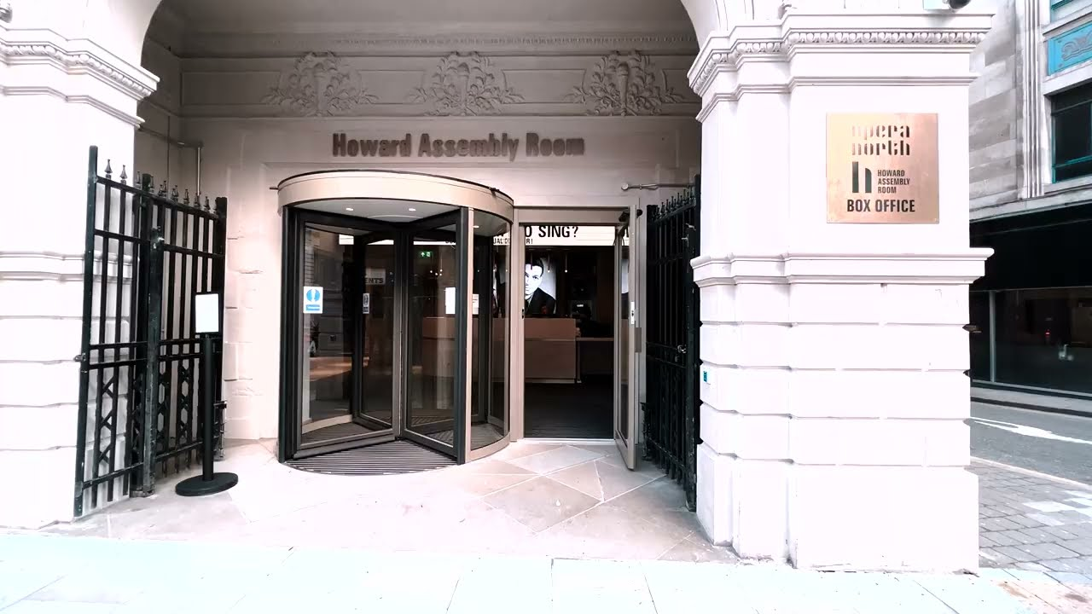 | The Opera North Box Office is at the Howard Assembly Room.  This is next door to Leeds Grand Theatre.
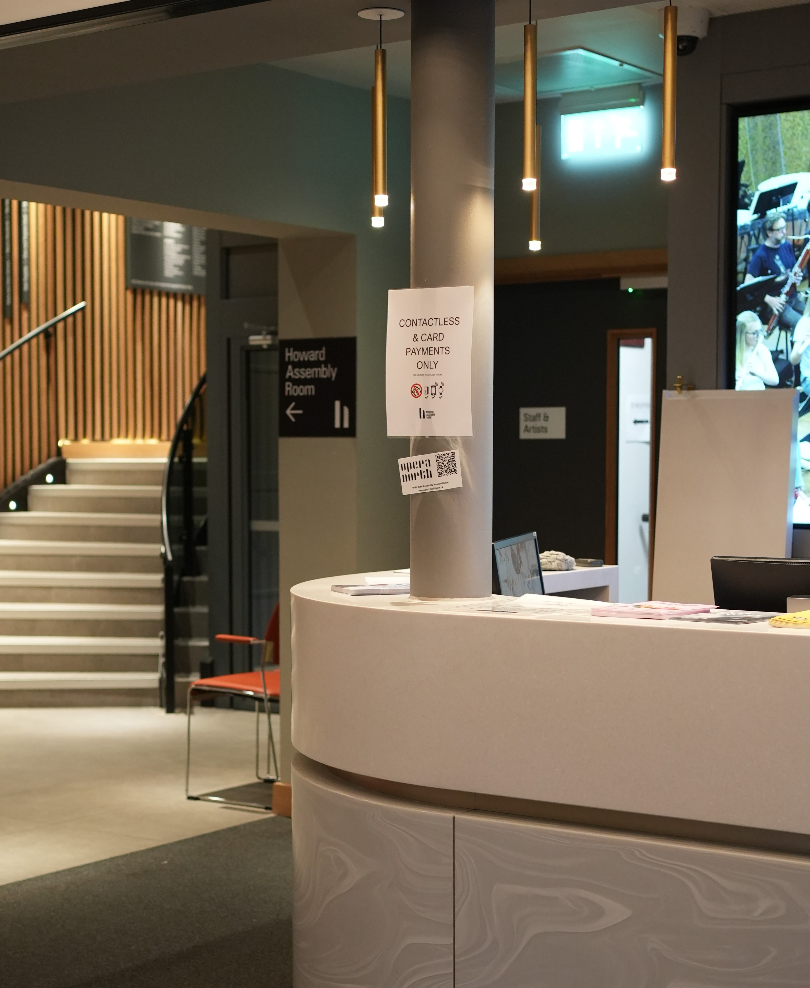 | When you go inside, the Box Office is straight ahead.
 | The Box Office staff can also answer questions and help you if you need support.

Arriving at the theatre
This is what the entrance of Leeds Grand Theatre looks like.

You can arrive from 12.30pm.
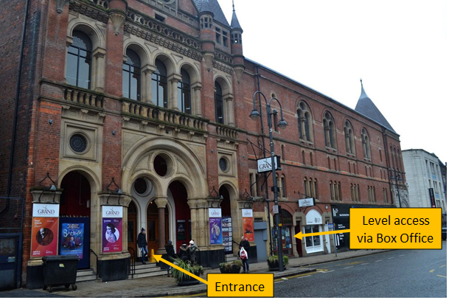 | The yellow labels show you where the entrances are.  You can go up some steps or use the lift in the Leeds Grand Theatre Box Office.
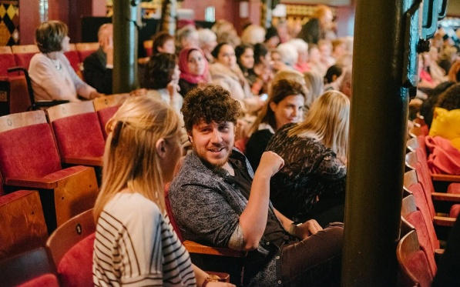 | It might feel quite busy when you arrive at the theatre.  This is because there will be a lot of people around.
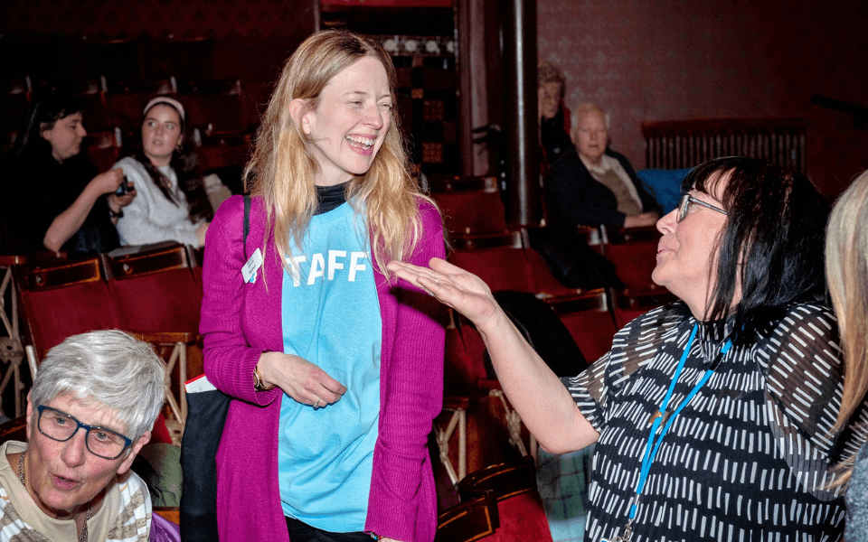 | Staff and volunteers will be there to help you.
   | Leeds Grand Theatre staff will have uniforms on.  Opera North volunteers will have staff t-shirts and Opera North lanyards.

Moving around the theatre

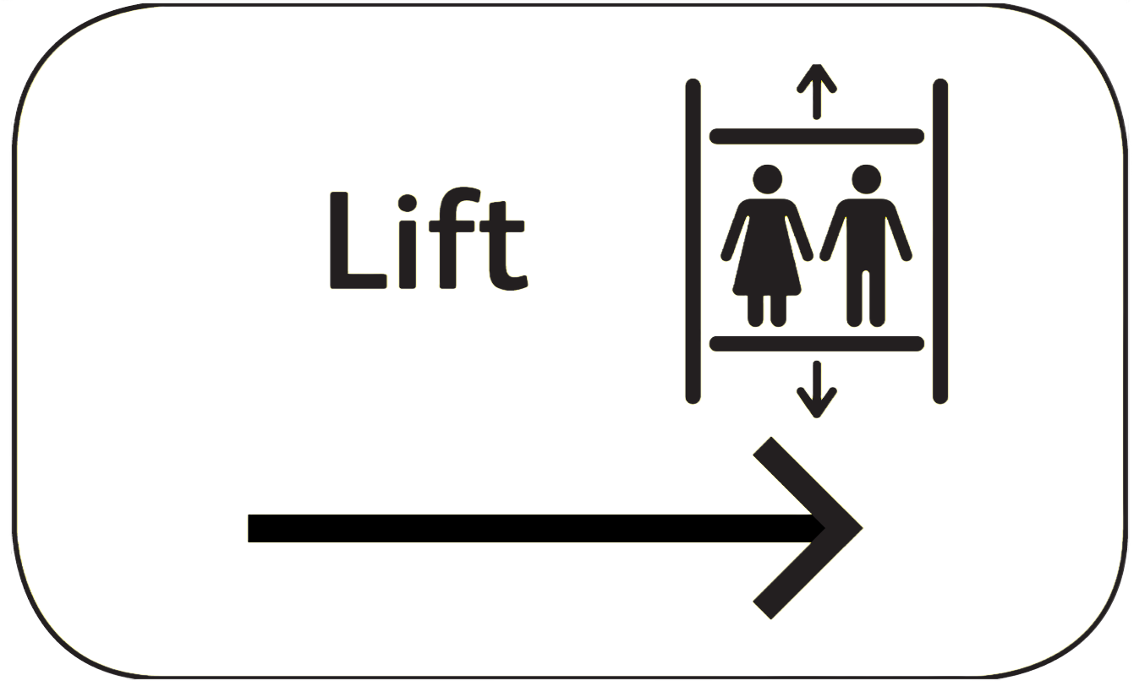 | There will be signs telling you where to go.  Staff will be nearby if you need help.
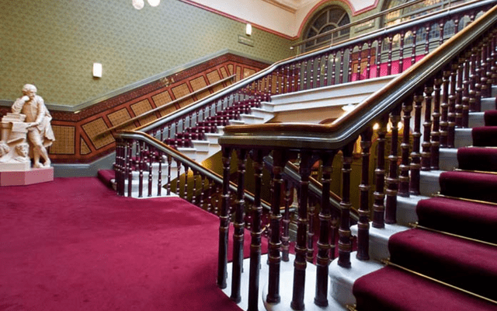 | The main staircase takes you to all the floors you need to go to.  There are banisters each side of the stairs.
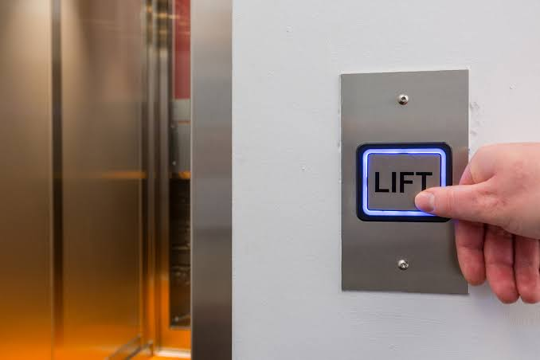 | You can also use the lifts.  There will be staff next to the lifts if you need any help.

Food and drink
 | You can buy snacks and drinks at Leeds Grand Theatre. There is no hot food.
 | You can bring your own food and drink with you.
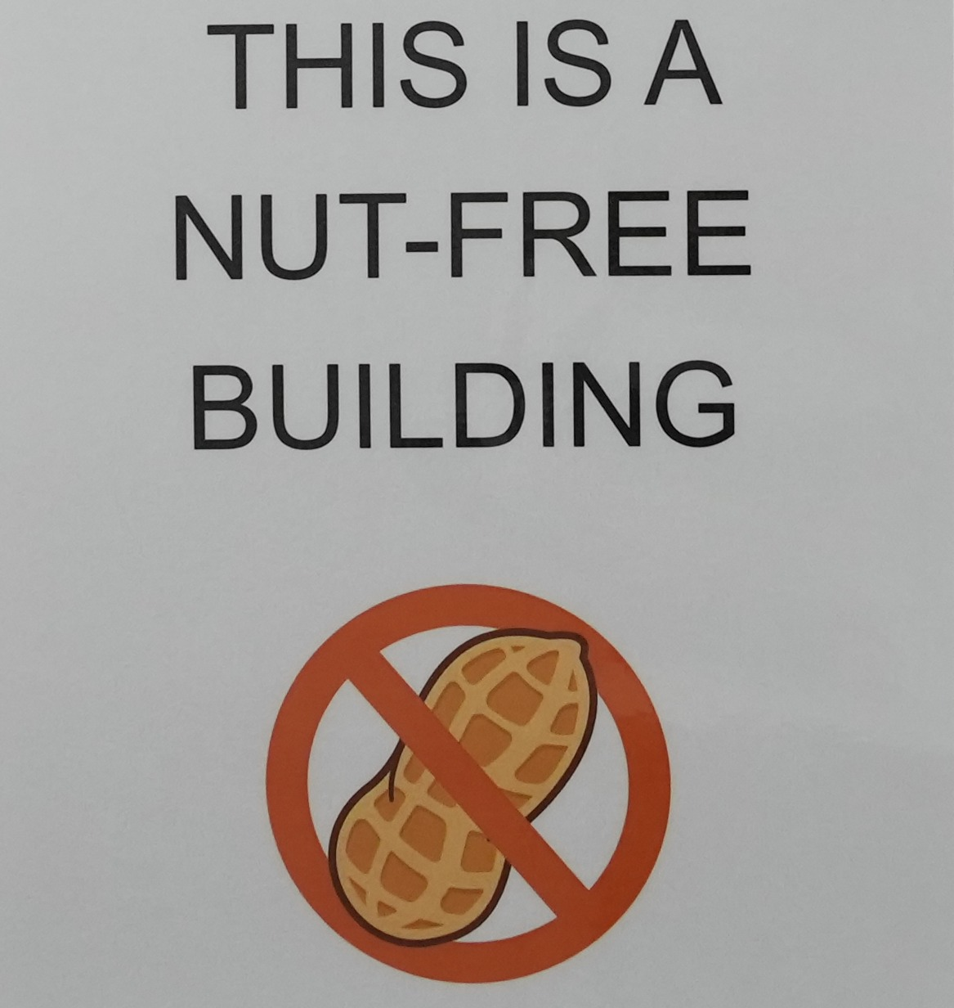 | Leeds Grand Theatre does not sell anything with nuts in. Please don’t bring any nuts in with you.
 | Tell a member of staff if you need some water. They will be happy to help you.

Quiet Spaces
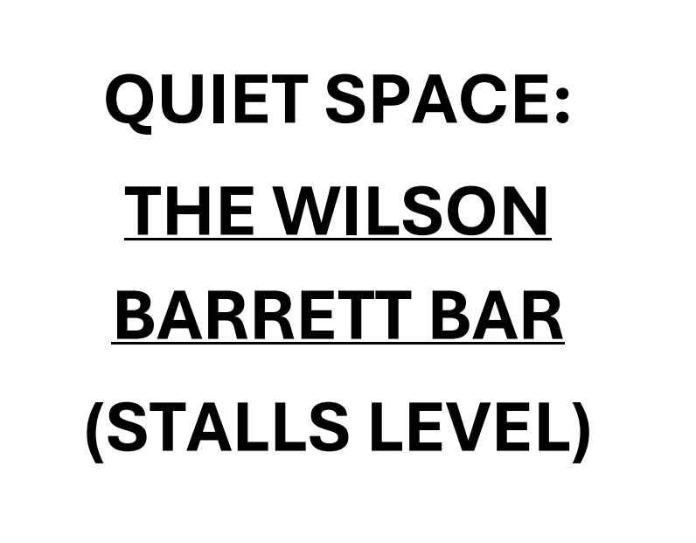 | There will be quiet spaces.  There will be signs towards them.
 | Staff and volunteers can also help you find them.
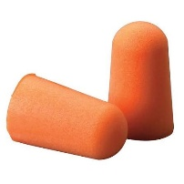 | Quiet spaces will have fidget toys and blankets and foam ear plugs that you can use.
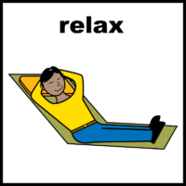 | The quiet space is a good place to relax and chill.

Toilets
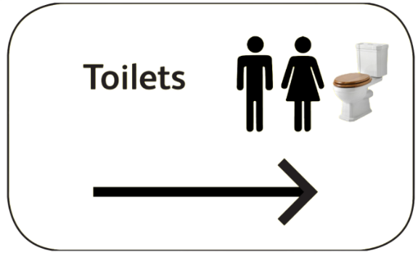 | There are Male and Female toilets on each floor.
 | There is an all-gender toilet at Stalls level. This is near the female toilets.  All-gender means that everyone can use it.
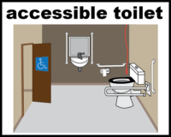 | There are wheelchair accessible toilets on the Stalls level and the Dress Circle level.
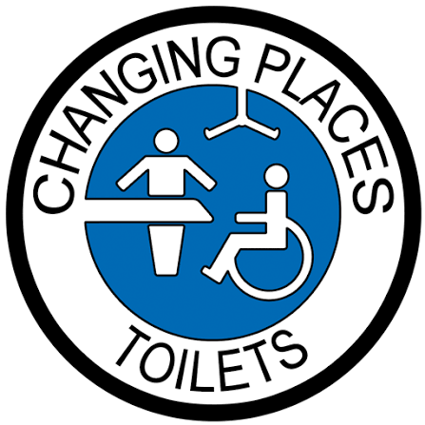 | Leeds Grand Theatre does not have a Changing Places toilet.

What the seats are like

The different sections are:
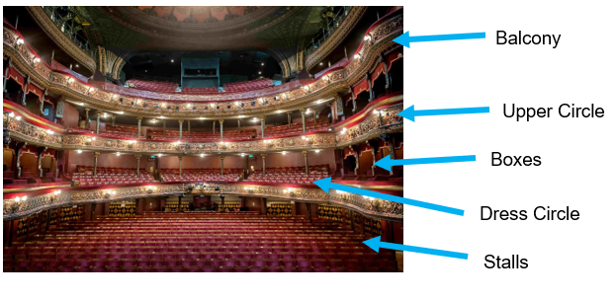
Your ticket will tell you which bit you are sat in:
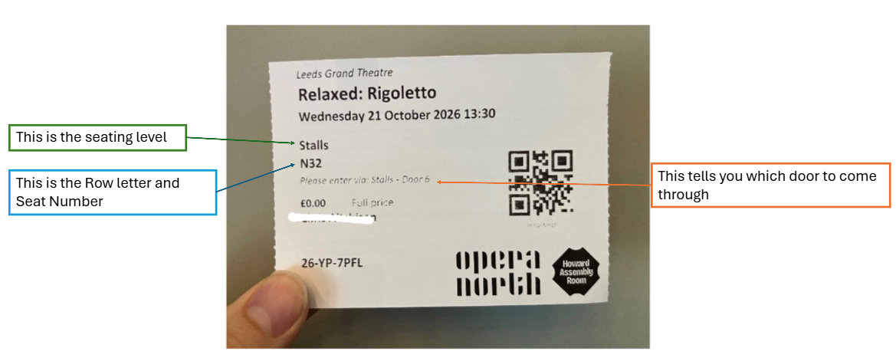

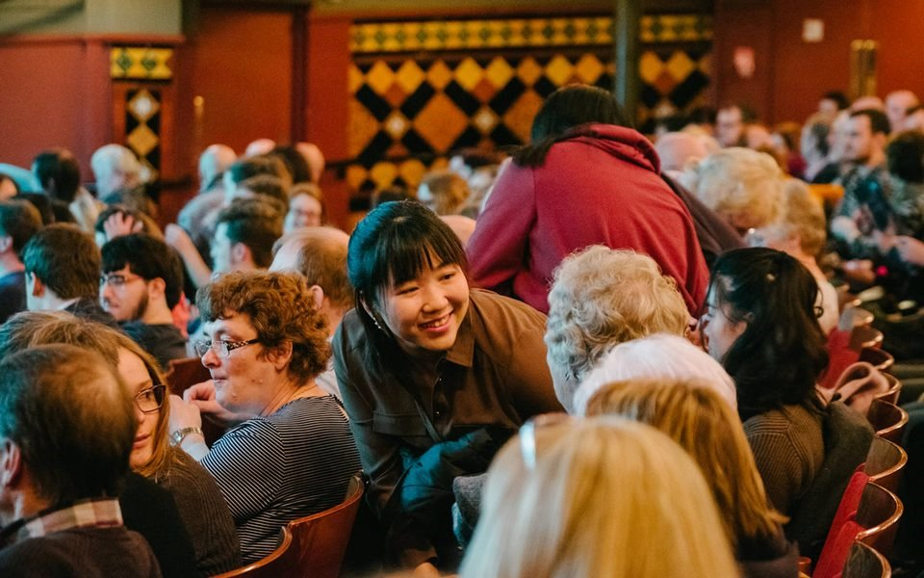 | There might be people sitting next to you, or you might have some empty spaces next to your seats.  If you are coming in a group, you will be sat together.
You can use a lift to get to wherever you are sitting.

Staff can help you and give you directions.

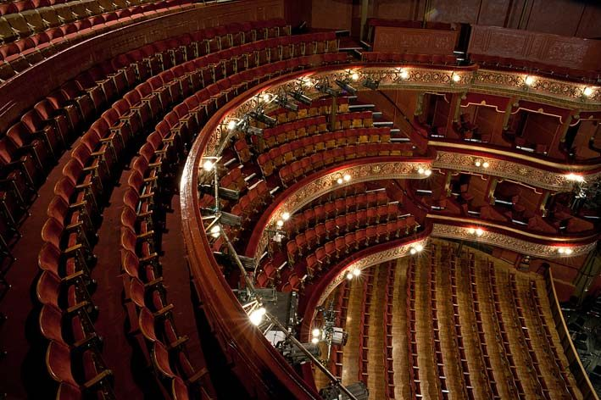 | The theatre looks very big but it won’t be full.  We will help you to find your seat.

What happens when the show starts

 | You will know when the show is ready to start because one of the performers will come on stage.  They will tell you about the show.
 | They will be underneath a light.  This means that you will be able to see them easily from your seats.
 | The performer will tell you about the show and what will happen.  You can read about the stage effects in the ‘Important things to know’ booklet.
 | Then the show will start.  We hope you enjoy it!

What happens during the show

 | During the show, you can:
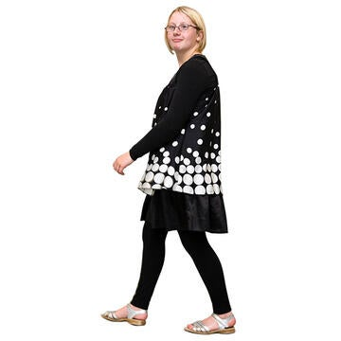 | Leave and come back to your seats whenever you want.
 | Go to the quiet space if you need a break.
 | Make noise if you want to. You don’t have to wait until the end of a song.
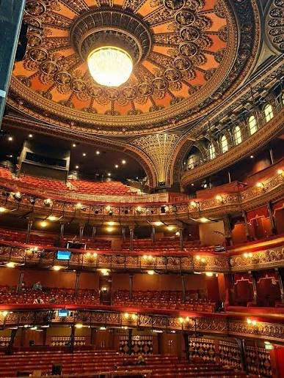 | Find your way around. The lights in the theatre will be turned on.
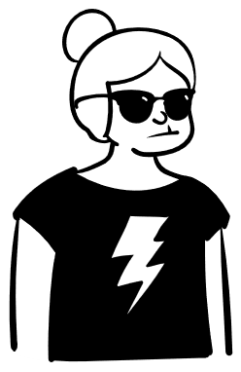 | The lights on stage will be less bright than usual.  You can bring sunglasses if you do not like bright lights.
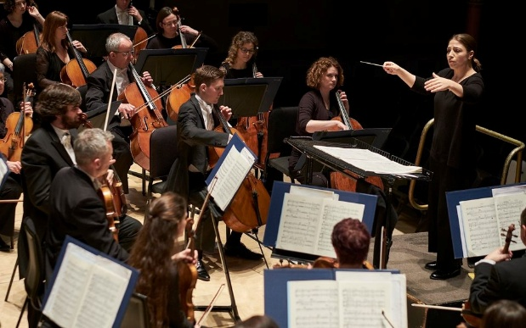 | The show will be quieter than usual.  Because operas use an orchestra, the music might still feel too loud.
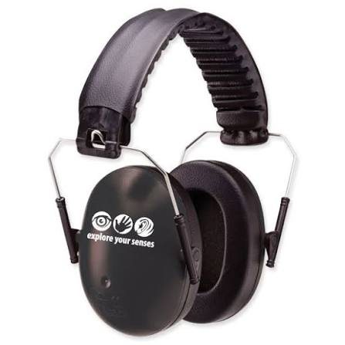 | You can bring some ear defenders or borrow some ear plugs.  You can cover your ears if you like.
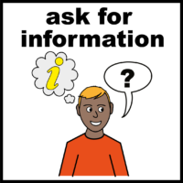 | If you have a question, you can ask the friendly members of staff. They will be happy to help you.

The interval
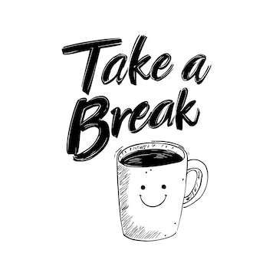 | About halfway through the performance, there is an interval.  This is when there is a break from the show.
 | It will last for 30 minutes.
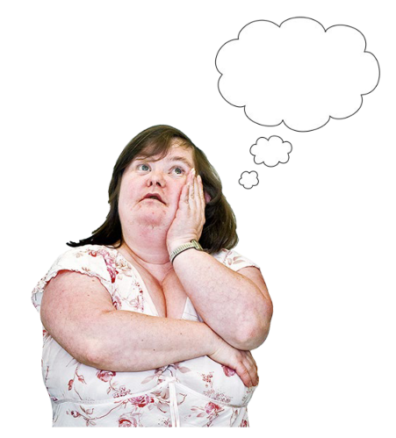 | You might want to move around, go to the toilet, have some food or a drink, or do something different.
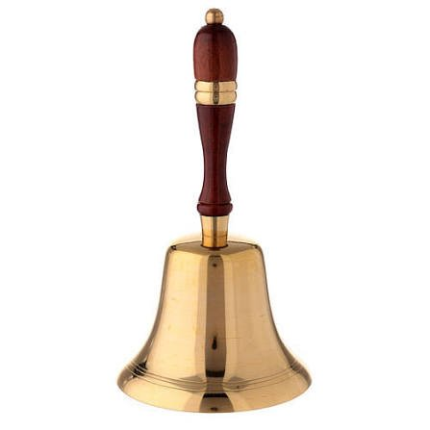 | Staff will tell you when it is time to sit down again by ringing a bell.  They will remind you what happened in the first half of the show.
 | They will also tell you about the second half.  The show will start again after this.

What happens at the end of the show
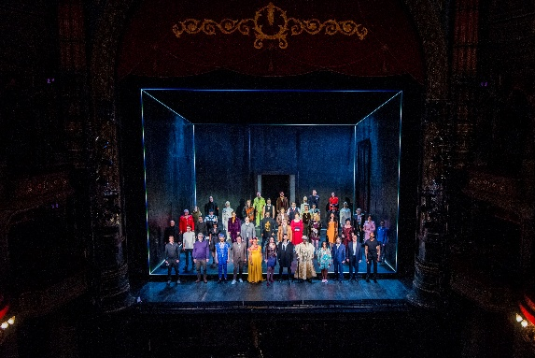 | At the end of the show, the cast will come back to the stage and take a bow.
 | If you want, you can show you liked the performance by clapping and cheering.
 | This might be loud, but you can cover your ears if you need to.
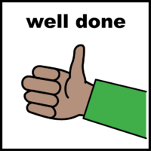 | Instead of clapping or cheering, you could say “well done” to the performers.

Leaving the theatre
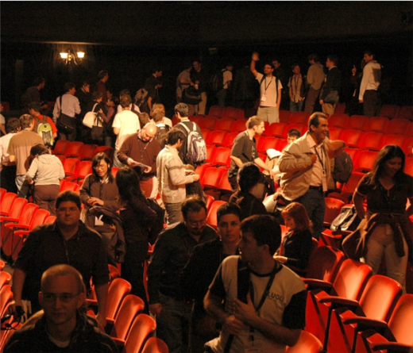 | It might feel quite busy when you are leaving the theatre.  This is because everyone will be out of their seats and going to the exits.
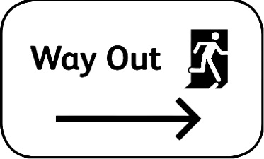 | There will be signs pointing to the exits and the friendly Leeds Grand staff and Opera North volunteers will help you get to them too.
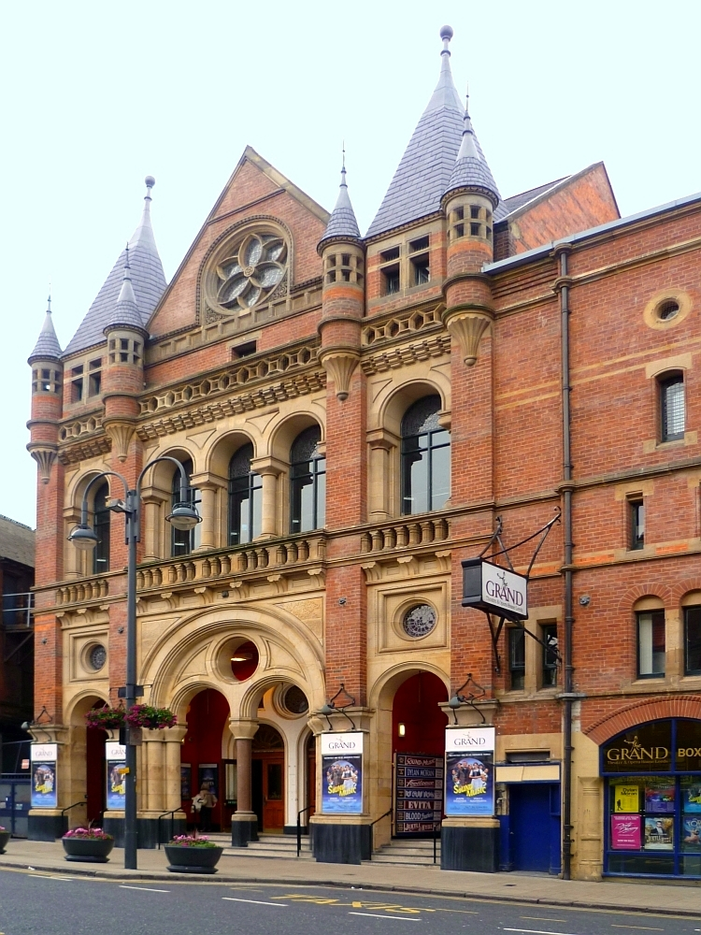 | When you leave, you will go out from the front of the theatre. This is the same place you came in.
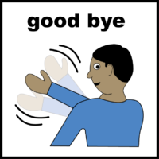 | Then you can say goodbye! We hope you enjoyed being at the Leeds Grand Theatre.

The End
 | Now you have read all about coming to the theatre.
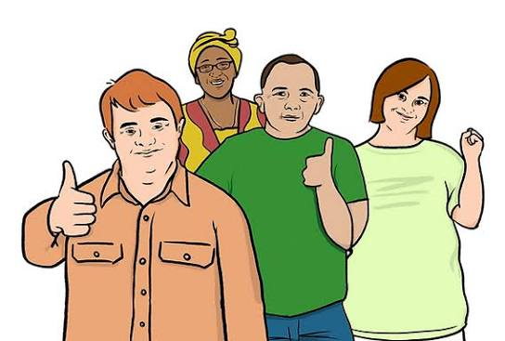 | We hope you liked it!
 | You might still have some extra questions.
You can ask your questions by calling the Opera North Box Office on 0113 223 3600.

You can also email them at boxoffice@operanorth.co.uk.

 | Our staff are very friendly, and they will be happy to help you.
 | Thank you for coming to watch Opera North’s production of Rigoletto.

