About the show

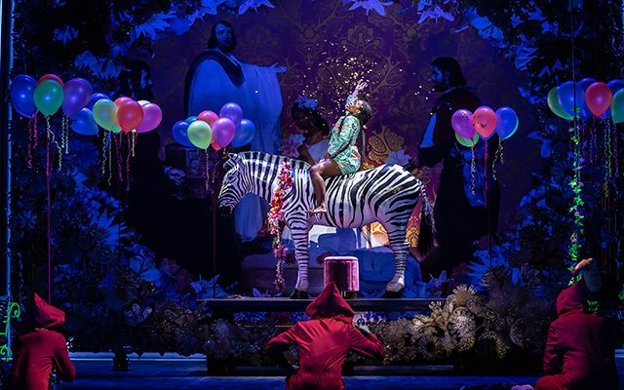 | Relaxed Performance of Rigoletto
 | At Leeds Grand Theatre
  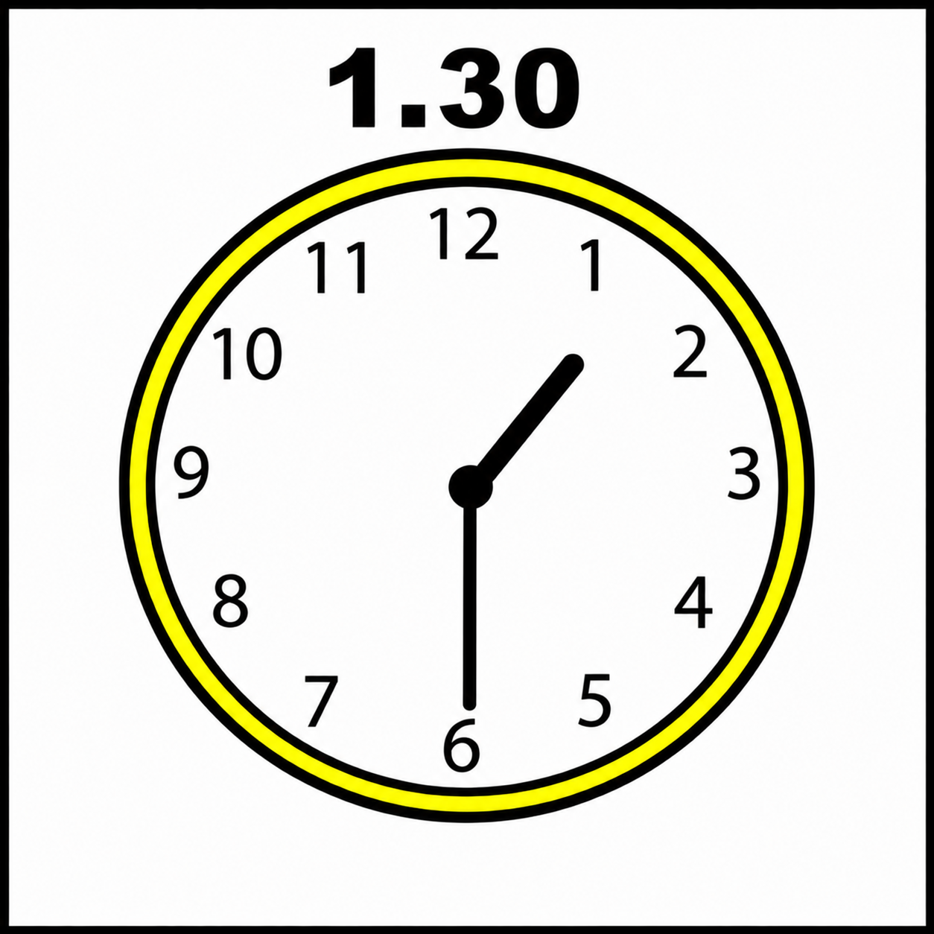 | Wednesday 21st October 2026  1.30pm

Who are the actors?
Siphe Kwani plays Rigoletto


Thomas Elwin plays the  Duke of Mantua   | Blaise Malaba plays  Count Monterone  
Yolisa Ngwexana plays  Gilda   | Indyana Schneider plays Maddalena  
Thomas Hopkinson plays Sparafucile   | Helen Évora plays Giovanna  
Christian Joel plays Marullo   | James Davies plays  Court Usher / Bodyguard  
Joseph Buckmaster plays Matteo Borsa   | Laura Kelly-McInroy plays  the Page  
Ross McInroy plays  Count Ceprano  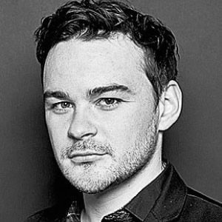 | Molly Barker-Knowles plays Countess Ceprano  

What will happen onstage?
   | The actors will be wearing make-up.  Some people will be wearing wigs.  This means their faces and hair will look different to their pictures.
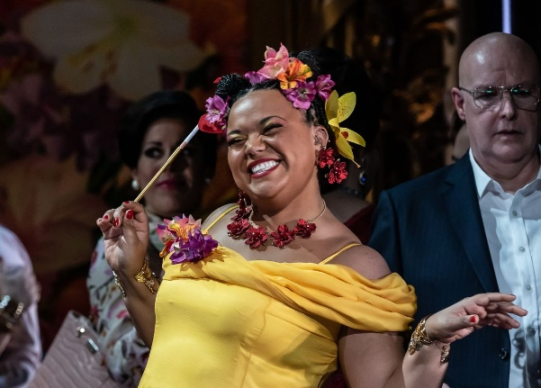 | The costumes are very colourful.
 | You will also see members of the Chorus of Opera North.  They will be singing and acting.
 | The Orchestra of Opera North will be playing their instruments in front of the stage.  You might not be able to see them.
 | The opera was written in Italian.  This means the songs are sung in Italian.
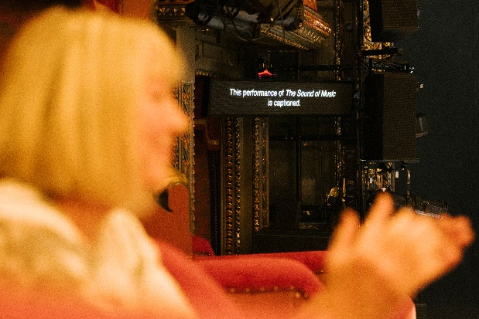 | You will be able to read the English versions on the screens next to the stage.
 | Or you can just sit back and listen to the beautiful music!

What is the story of Rigoletto?
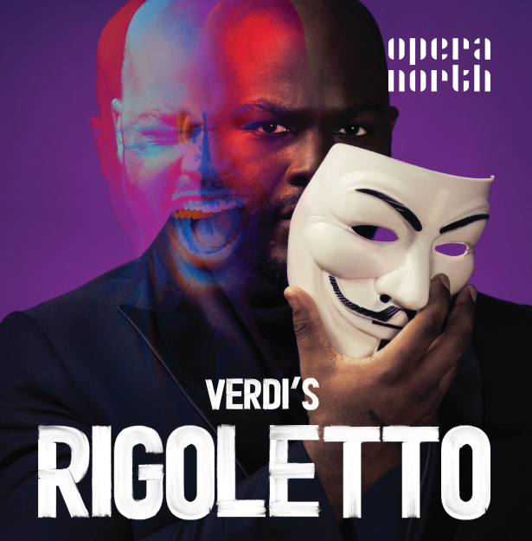 | This is the story of Rigoletto.
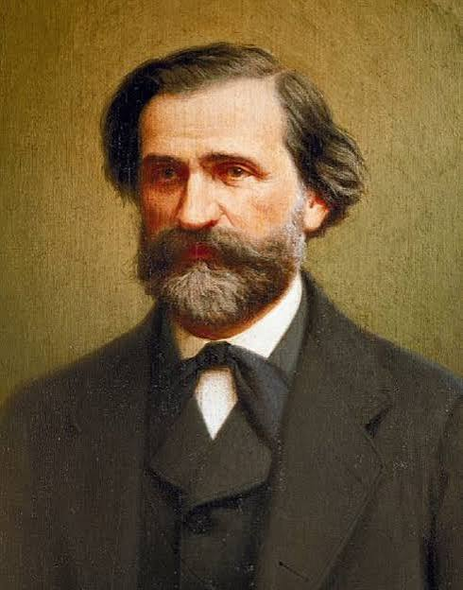 | Rigoletto is an opera written by the composer Giuseppe Verdi.
 | A composer is someone who writes music.
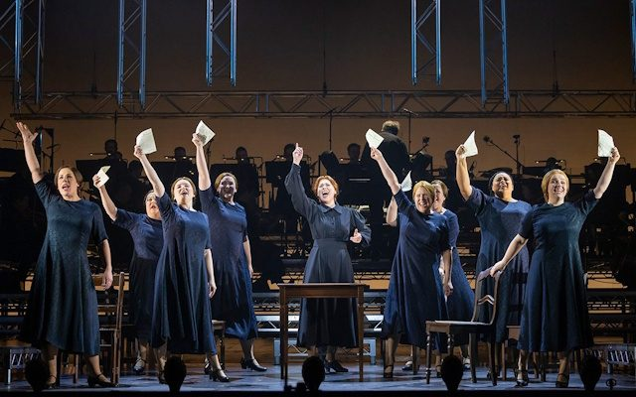 | An opera is a stage play where the actors tell the story by singing all of their lines.
 | In the show, some violent things happen.
 | This includes hurting and kidnapping people.
 | This might make you feel worried.
 | It might also make you feel sad.
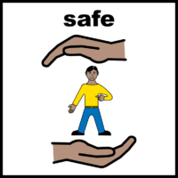 | Remember that the actors are safe.
 | Talk to someone if you need help.
 | Here is the story of Rigoletto...
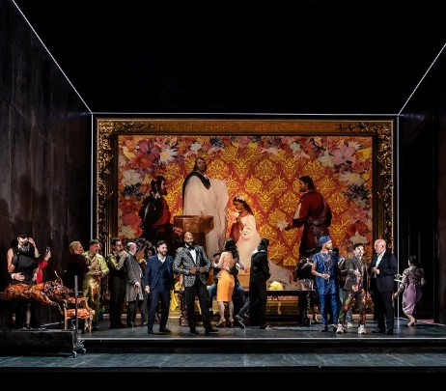 | The story takes place in the world of the Duke of Mantua.  It starts in his art gallery.
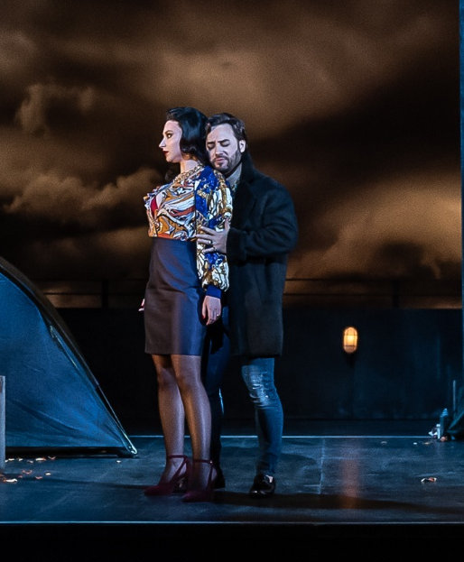 | The Duke is a nasty leader who treats women badly.
 | Rigoletto is the court jester.  He makes cruel jokes.
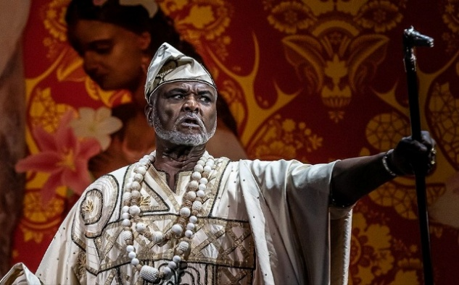 | He says bad things about a  man called Monterone.  Monterone is angry.
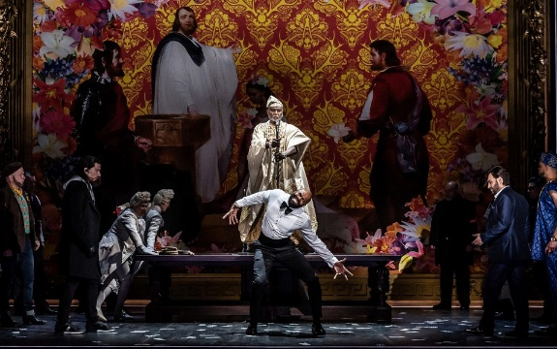 | Monterone puts a curse on Rigoletto.  A curse is an evil spell.
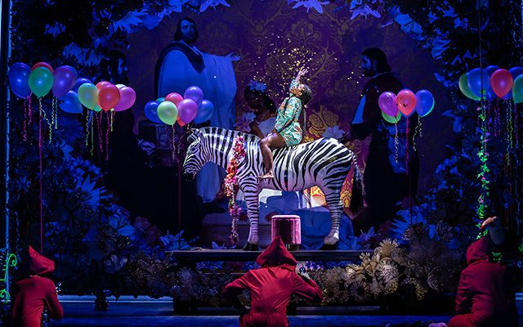 | We then meet Gilda.  Gilda is Rigoletto’s daughter.
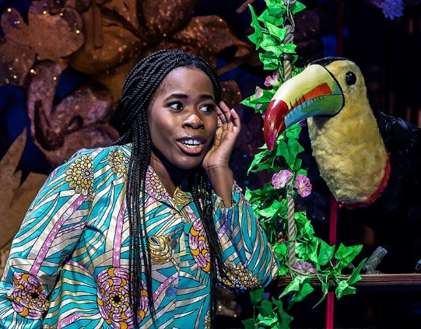 | Rigoletto hides Gilda away from the world.  She imagines things to make her life more exciting.
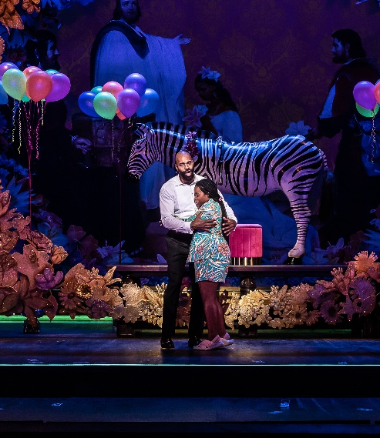 | Rigoletto tries hard to protect Gilda.  This is because he is worried that she will get hurt.
 | Gilda falls in love with a young man.  This man is the Duke. He is wearing a disguise.
Later, Gilda is kidnapped by men in masks.

They take her to the Duke.

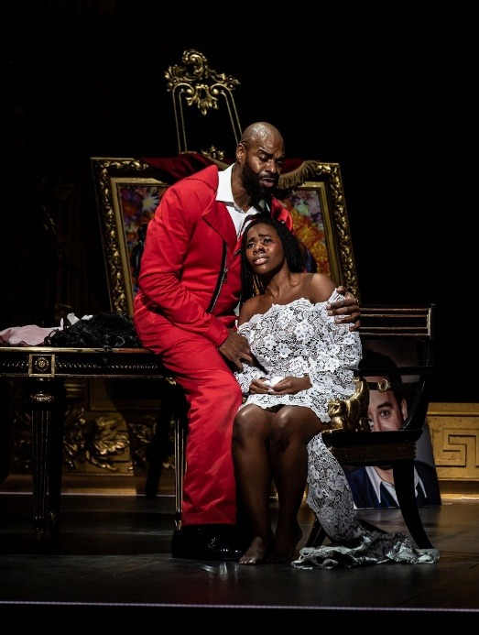 | Rigoletto finds out what has happened.  He is very sad and angry.
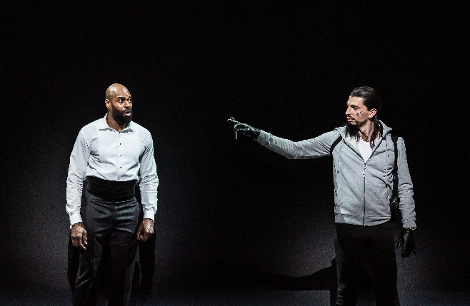 | Rigoletto asks a man called Sparafucile to kill the Duke.
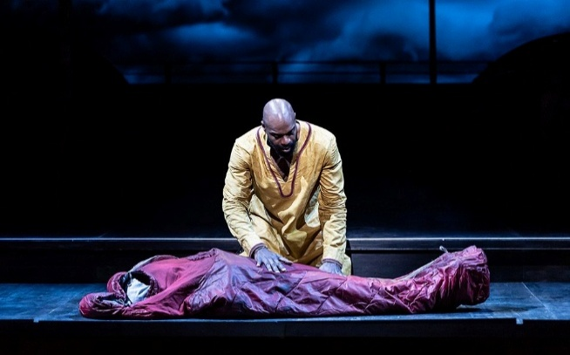 | But the plan goes terribly wrong.
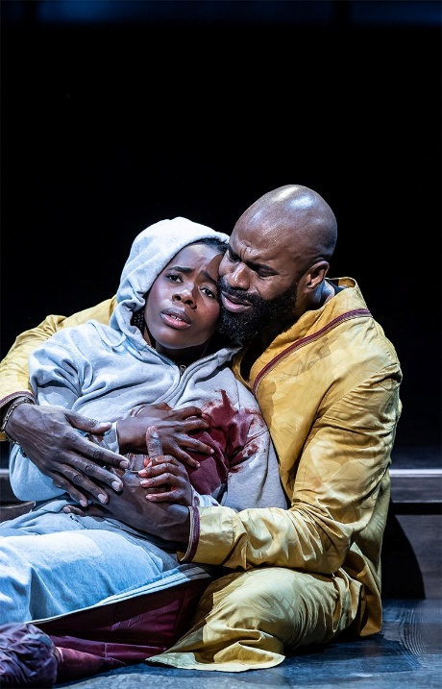 | Gilda is killed.  Rigoletto is very sad.
 | This is the end of the show.
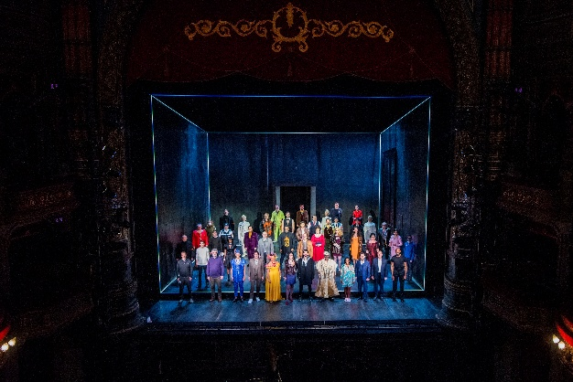 | The cast will come and take a bow after this!

The End
 | Now you have read all about the show.
 | We hope you liked it!
 | You might still have some extra questions.
   | You can ask your questions by calling our Box Office on 0113 223 3600.  You can also email them at boxoffice@operanorth.co.uk.
 | Our staff are very friendly, and they will be happy to help you.
 | Thank you for coming to watch Opera North’s production of Rigoletto.

